1.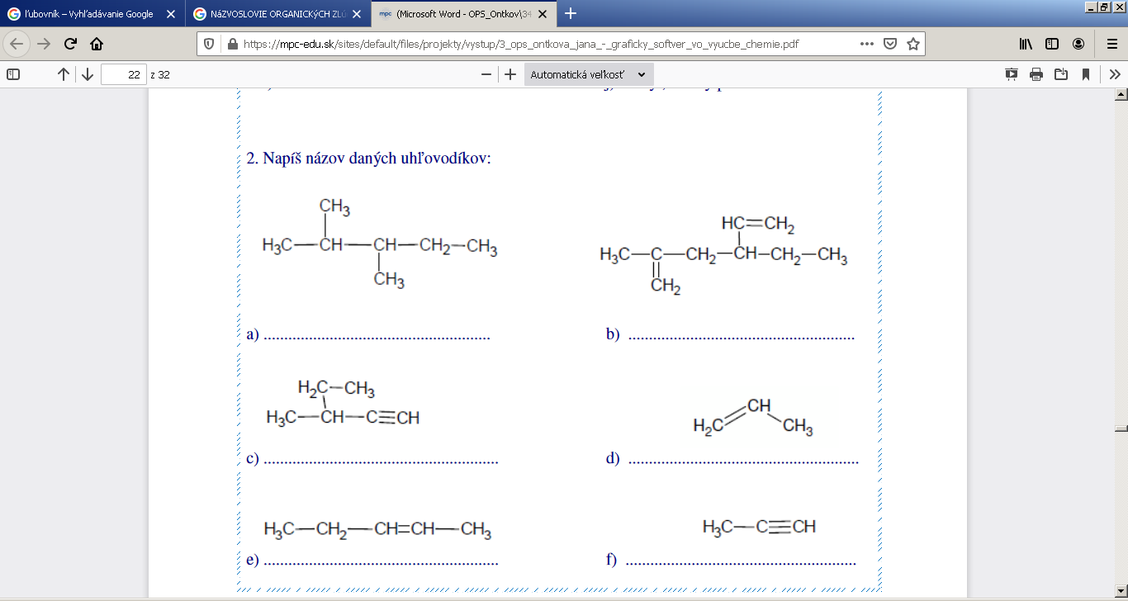

____________________________________________________________________________

2. 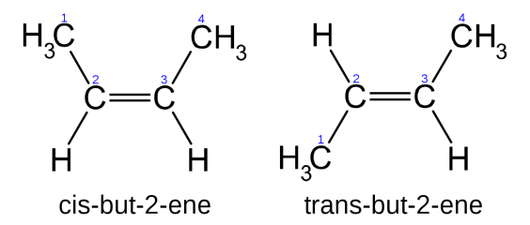_______________________________________

3. 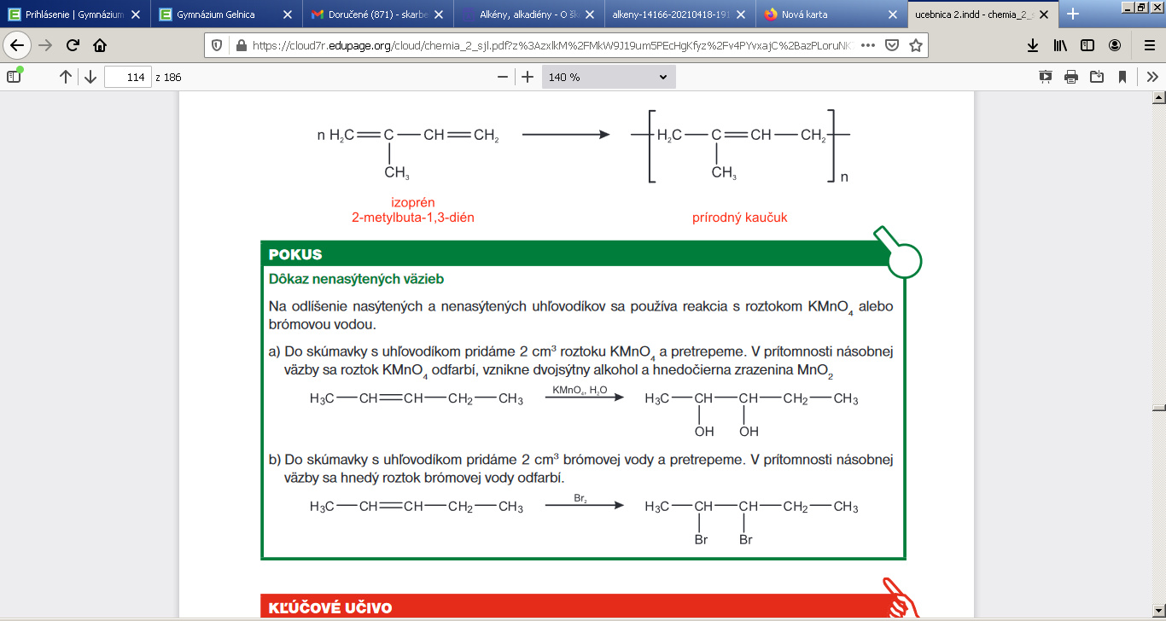____________________________________________

4.